Ideation Phase
Brainstorm & Idea Prioritization Template

Date | 20 Feb 2026
Team ID | LTVIP2026TMIDS79198
Project Name | ResolveNow – Online Complaint Registry Platform
Maximum Marks | 4 Marks

Brainstorm & Idea Prioritization Template:
Step-1: Team Gathering, Collaboration and Selection of Problem Statement
Problem Statement
In many organizations and public services, people face difficulties in registering complaints and tracking their resolution status. Traditional complaint systems are slow, manual, and lack transparency. Users often do not receive updates, and authorities struggle to manage complaints efficiently.
Discussion Summary
The team discussed common real-world issues such as:
- Lack of centralized complaint management systems
- Delay in complaint resolution
- No proper tracking or status visibility
- Poor communication between users and administrators

Reference: https://www.atlassian.com/agile/project-management
Step-2: Brainstorm, Idea Listing and Grouping
During the brainstorming phase, the team generated multiple ideas to design an efficient and user-friendly complaint management system. The discussion focused on identifying features that would simplify the process of registering and managing complaints while improving transparency and communication between users and administrators. Various ideas were proposed, including an online complaint submission portal, secure user registration and login system, complaint categorization, real-time complaint status tracking, and an administrator dashboard for managing and resolving complaints.
Additional suggestions such as notification updates, complaint history tracking, search and filtering options, and secure database storage using MongoDB were also considered. After listing all ideas, they were grouped into different categories such as user features, administrative functionalities, system management features, and communication enhancements. This structured grouping helped the team clearly understand the project requirements and organize the system features effectively before moving to the prioritization stage. The brainstorming session encouraged collaborative thinking and ensured that both user convenience and system efficiency were taken into account while shaping the final solution.
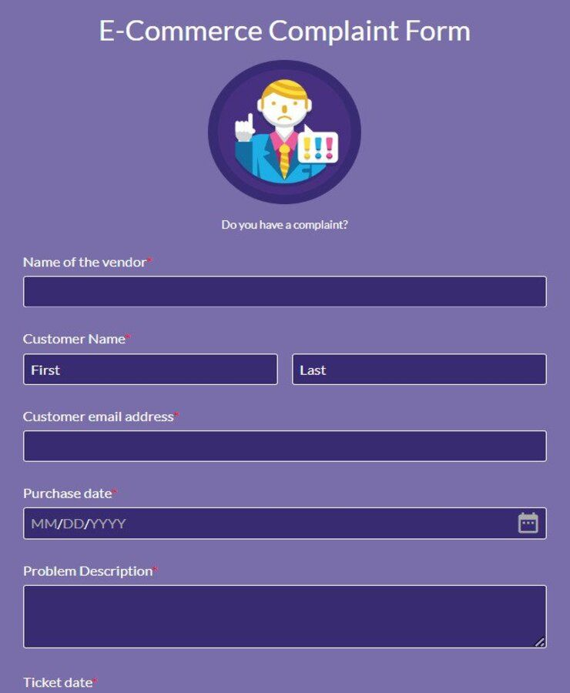

Step-3: Idea Prioritization
After completing the brainstorming and grouping process, the team evaluated all proposed ideas to determine which features should be implemented first based on importance, feasibility, and overall impact on users. The prioritization was carried out by considering factors such as ease of implementation, usefulness to users, system performance, and project timeline. Core functionalities like user registration and login, complaint submission, complaint status tracking, admin dashboard management, and secure database integration were identified as high-priority features because they form the foundation of the complaint registry system. Features such as complaint categorization, search and filtering options, and complaint history were categorized as medium priority since they enhance usability but are not essential for initial deployment. Advanced features including notification alerts and analytical reporting were considered future enhancements to be implemented later. Through this prioritization process, the team finalized the development of the Resolve Now Online Complaint Registry System, ensuring that the most essential and impactful features were developed first to deliver an efficient and practical solution.

